A Project Report on

COMPETITIVE ANALYSIS OF LEADING

TRAVEL AGGREGATORS

**by**

**Team Leader : Janne swathi (20AT1A05H0)**

**Student 1 : Balapala Madhan (20AT1A0572)**

**Student 2 : Rajasekhar gari Megha s(20AT1A0586)**

**Under the Guidance of**

**MRS.M. JAYA SUNITHA , M.Tech**

**Associate Professor**



**DEPARTMENT OF ELECTRONICS AND COMMUNICATION ENGINEERING**

**G. PULLAIAH COLLEGE OF ENGINEERING AND TECHNOLOGY**

**(Autonomous)**

(Approved by AICTE | NAAC Accreditation with ‘A’ Grade | Accredited by NBA (ECE, CSE, EEE, CE) |

Permanently Affiliated to JNTUA)

ABSTRACT

Tourism has been a major social phenomenon in societies all over the world. It is driven by the human desire for new experiences, and the desire to be educated and entertained. The spread of education and the technological improvements in communication have strengthened the basic human thirst for new knowledge and experience and have fostered a desire to know more about different parts of the world.Tourism has been revolutionised with the emergence of tourism aggregators, i.e. web-based portals that provide travellers with services such as travel, accommodation, and tour planning and booking. The tourism aggregators have reduced information search costs, and have increased the awareness of tourists of potential destinations. This has enabled some innovative trends in tourism, including eco-tourism, adventure tourism, heritage tourism, medical tourism, pilgrimage tourism, and so on. The objective of the study is to compare the competitiveness of Indian tourism aggregators using the Analytic Hierarchy Process (AHP). AHP is a technique that is used to structure multi-criteria decisions, allowing both quantitative and qualitative comparisons between alternatives (Saaty and Forman, 1992; Saaty, 2008). The criteria used for the study include price, process, ease of access, and customer service. The tourism aggregators selected for the study include Yatra, Makemytrip, Goibibo, Cleartrip, Expedia, and Kuoni-SOTC. Keywords: Tourism Aggregators, Travel Accommodation, Tour Planning, Analytic Hierarchy Process International Journal of Marketing and Business Communication.

**Contents**

**Abstract**

**Contents**

**List of Figures and Tables**

**CHAPTER 1 INTRODUCTION**

**CHAPTER 2 LITERATURE REVIEW**

**CHAPTER 3 PROPOSED METHOD**

**CHAPTER 4 EXPERIMENTAL RESULTS**

**CHAPTER 5 APPLICATIONS/ADVANTAGES**

**CHAPTER 6 CONCLUSIONS & FUTURE SCOPE**

**CHAPTER 1**

**INTRODUCTION:**

In the twenty-first century, tourism has emerged as a strong economic force for development. According to the 2015- 16 report of Ministry of Tourism, Govt. of India, ‘Tourism is accepted as the potent engine for inclusive social economic progress at universal level through its forward and backward linkages and ability to create employment in the economy.’ Tourism has direct role in employment generation and poverty eradication sustainably for all segments of society. The Government of India seems oriented in this direction. The gradual increase in FTAs and tourism revenue is an indicator of Tourism India being in forefront. In 2015 FTAs in India increased by 4.5%, and the corresponding Foreign Exchange Earnings (FEEs) from tourism witnessed a growth of 9.6%. Government initiatives like TVA1 with ETA2 (e-Tourist Visa), 24x7 multi-lingual tourist help is now witnessing the result; in 2015-16 4,45,300 tourists used e-Tourist facility. The facility is available at sixteen airports for one hundred and fifty nationalities. Two tourism schemes were also launched; Swadesh Darshan and PRASAD3 . Tourism India is a 365 days’ tourist destination. The Indian tourism industry can be classified in variety of ways based on criteria:

1 Tourist Visa on Arrival

2 Electronic Travel Authorisation

3 Pilgrimage Rejuvenation and Spiritual Augmentation Drive

Tourism is a part of everyone’s life. A situation where people from one country or region visit another country or region for a short period of time. The tourism industry in India has gained great importance due to the rich heritage, culture and the various other facilities that they offer in terms of health, relaxation and luxury. Since the year 2000 tourism industry has been giving a number of benefits to India. The number of foreign tourist’s visits to India have been on a gradual rise, which has also been contributing to foreign exchange earnings to the country.

**CHAPTER 2**

**LITERATURE REVIEW:**

Accommodation and Catering Growing consistently since 1995/96 from just 120 hotels with about 18,000 branded/organized rooms to a record 887 hotels with a room count of 1,13,622 in 2015/16. The growth in hotels and restaurants segment was estimated at 21.5% during 2015/16. Also, hotel and tourism ranked as one of the top ten sectors to attract the highest FDI, contributing 3% of the total inflow. Further, the introduction of GST (Goods and Services Tax) will improve the growth factor by decent points as it will replace the indirect taxes on all goods and services. Leisure travel is on rise, the WTT+S estimates that leisure travel spending (inbound and domestic) generated 83.2% of the direct travel and tourism GDP (Rs.5,045.5bn) in comparison to 16.8% from business travel spending. The market-wide occupancy was healthy at 63.4% in 2015/16. RevPAR (Revenue Per Available Room) was recorded at Rs.3,512 in 2015/16, a significant growth of 6.1% over the preceding fiscal. The existing room supply grew by 5.5% in 2015/16 totaling to 1,13,622 rooms (highest supply growth in Agra followed by Ahmedabad and New Delhi)

**TRANSPORTATION:**

Transportation During 2015/16, transport industry registered strong growth. In aviation sector India is now 3rd largest market in domestic air passenger traffic at 100 million in 2016, behind only US (719 million) and China (436 million). The Indian passenger vehicle industry has grown by 7.2% during FY2016, in line with ICRA’s expectation of 7%-8% growth during the year. The domestic passenger vehicle sales has been supported by new model launches by incumbents as well as new entrants, discount push from OEMs and improved customer sentiments in the backdrop of recovery in the overall economy. The passenger car segment, which constitutes 73% of the domestic volume, grew by 7.9% followed by 6.3% in utility vehicles and 3.6% in the van segment.

**TRAVEL AGENTS AND TOUR OPERATORS:**

They are one of the main parties in tourism business. Travel agents mainly work on fees for arranging tourism products for customers. Tours operators means any person engaged in the business of planning, scheduling, organising or arranging tours (which may include arrangements for accommodation, sightseeing or other similar services) by any mode of transport, and includes any person engaged in the business of operating tours in a tourist vehicle or a contract carriage by whatever name called, covered by a permit, other than a stage carriage permit, granted under the Motor Vehicles Act, 1988 (59 of 1988) or the rules made thereunder (CBEC, Department of Revenue, Ministry of Finance, Government of India).

**ONLINE TRAVEL SERVICES:**

India’s online travel segment constitute 41% of the overall Indian travel market (2014). The online travel market, estimated at US$ 9.1 billion (2014), comprised air travel (US$ 5.1 billion), rail (US$ 3.1 billion), hotels (US$ 0.8 billion), and others (US$ 0.1 billion). Online penetration in travel and tourism booking is expected to rise to 46% in 2017. Internet penetration in India is low at 17%. Key online travel agencies are Makemytrip (47%), Cleartrip (20%), Yatra.com (20%), and others (13%). Online hotel segment in India is under-penetrated, with only 10% of hotels accepting bookings online, while the overall user-base of people seeking information on hotels online was very high. Online penetration of airline in travel segment stood at 52%, followed by rail travel at 43%, \hotel at 10%, and car rentals at 11%.

**TRAVEL AGGREGATORS:**

Aggregators refers to a web site or computer software that aggregates a specific type of information from multiple online source. In other words Aggregator website search for deals across multiple website and shows up the results in one place. Travel Aggregator makes life simple e.g. one can sit down in front of system and search on individual website for offers and deals instead the comparative offers and deals can be searched in one go by visiting aggregators website as yatra.com, makemytrip.com, tripadvisor,com, goibibo.com etc. that will check hundreds of airlines at once and show you the one range from least priced to most expensive in an order. Travel Aggregators or Meta-search sites are multiple travel search engines in one place. Manual searching individual site is tedious and doesn’t guarantee cheaper product. There are multiple Aggregators are available in Indian market for tourism products.

**CHAPTER 3**

**PROPOSED METHOD:**

The analytic hierarchy process (AHP) is a technique that is used to structure multi-criteria decisions, allowing both quantitative and qualitative comparisons between alternatives. The first step of AHP is that of formulating the problem and stating the objective. The second step is that of identifying the criteria that contribute to the objective. The third step is that of performing pairwise comparisons between the criteria, and between the alternatives under each of the criteria. The weightages for each of the criteria and for each alternative under each of the criteria are obtained from the pairwise comparison matrices. The final step is that of combining the weightages of the alternatives, and selecting the alternative with best weighted average (Saaty and Forman, 1992; Saaty, 2008).

The criteria used for the study include price (x1), product (x2), convenience (x3), and customer service (x4).

The price factor includes aspects such as the fares/rates, discounts, promotional offers, booking charges, different payment modes, and so on. Of these, the most important was considered to be the fares/rates, as these can vary widely due to dynamic pricing. To compare the fares/ rates offered by different tourism aggregators, a sample of flight bookings and hotel bookings was taken for a fixed set of sample periods, and their mean, standard deviation, and maximum values were compared.

The product factor includes consideration of the variety of products offered, the number & range of service providers hosted, the availability of flights/hotel bookings, the attractiveness of design of the website, the features included on the website, and so on. This was assessed by comparing the website design for the tourism aggregators.

The convenience factor is concerned with aspects such as the ease with which customers can search for/find the website and information related to products on the website, the ease of buying the product, and so on. To assess these aspects, search engine optimization (SEO) and web analytics statistics were collected from the analytics websites https://www.similarweb.com, www. freeseodoctor.com, and <https://seositecheckup.com>.

Technology has facilitated the access for tourism. Travellers opt for interactive choice, product and service quality and sufficient necessary information to help them deciding faster. Poon and Joseph (2001) posit that electronic commerce increases customers’ purchasing and transaction benefits. Tourism has crossed borders and regions and has become global phenomenon in the age of technology. According to Rayport and Sviokla (2000), the intangible nature of the services makes technology-arbitrated models readily accepted in services. ‘Online travel agents provide a point of contact for customers through World Wide Web to facilitate customers in searching for appropriate travel planning, which is then booked and ticketed by the online travel agents’. Travellers today look for interactive, quality, fast and anytime accessible tourism services from aggregators. Global travel industry has added technology as an essential tourism element.

The customer service factor focuses on the quality of service support offered by the tourism aggregators to their customers. This is assumed to be reflected in customer satisfaction as well as customer complaints. To assess this factor, the customer reviews, complaints, and ratings recorded on the consumer feedback website www.mouthshut.com were collected and compared for the tourism aggregators. The most important criterion was found to be customer service, followed by convenience, product, and finally price.

Tourism is service dominant product and it’s a fragmented industry consisting of many small-sized service providers such as restaurants and lodging facilities as bed and breakfast establishment and tour operators (Wertner & Klein, 1999). Tourism is an intangible and experiential good; that is, a sample test or prior assessment of standard is extremely difficult without actual experience of real purchase. This gives rise to the high risk involved in decision making (Roehl & Fesenmaier, 1992), leading to extensive search for information. Second, travel decision making involves a complex and multi-faceted decision process that is influenced by numerous kinds of constraints (Jeng & Fesenmaier, 2002). Thirdly, travel decisions are highly-context driven and individual-based (Gretzel, Hwang, & Fesenmaier, 2006). The critical success points in aggregators business are Price, Product, Convenience, and Customer Service. Smith states that availability of free information does not ensure that customers will use it; this will depend on reliability of and trust in the supplier. If the services offered by these websites are increased coupled with display of relevant information about destinations, the Indian customer would be encouraged to visit these websites and use them for vacation planning.

**CHAPTER 4**

**EXPERIMENTAL RESULTS:**

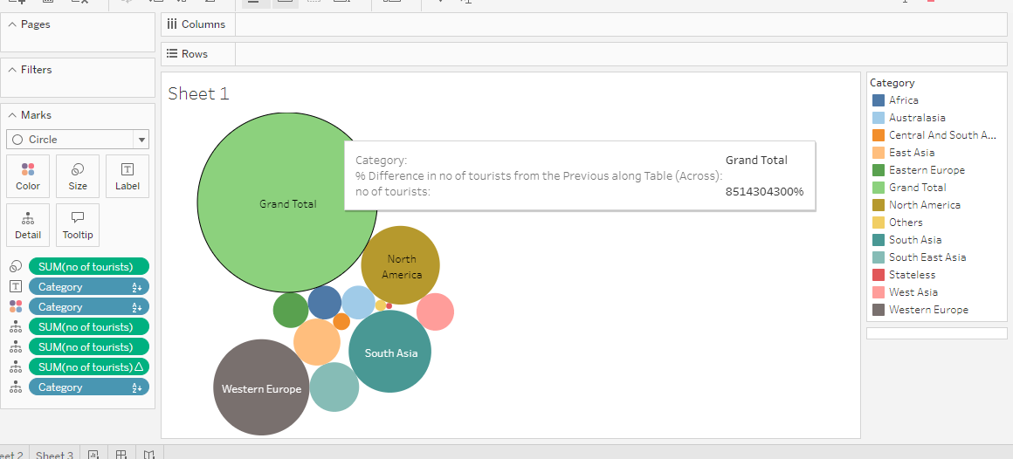

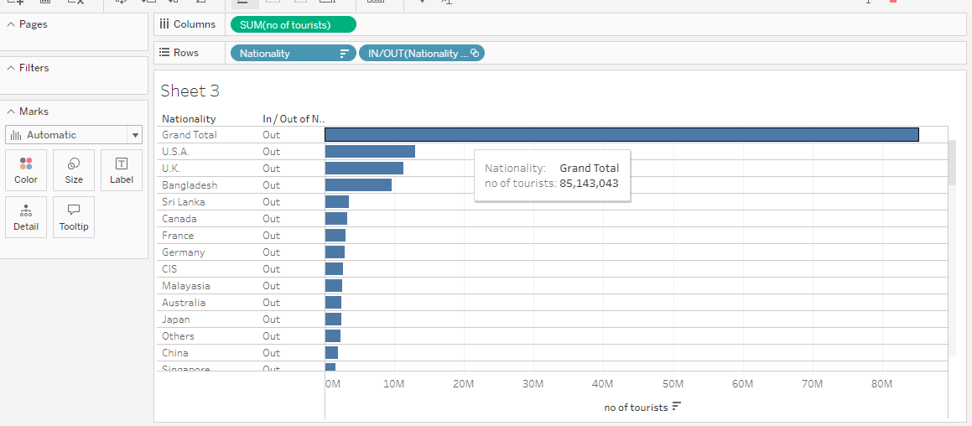

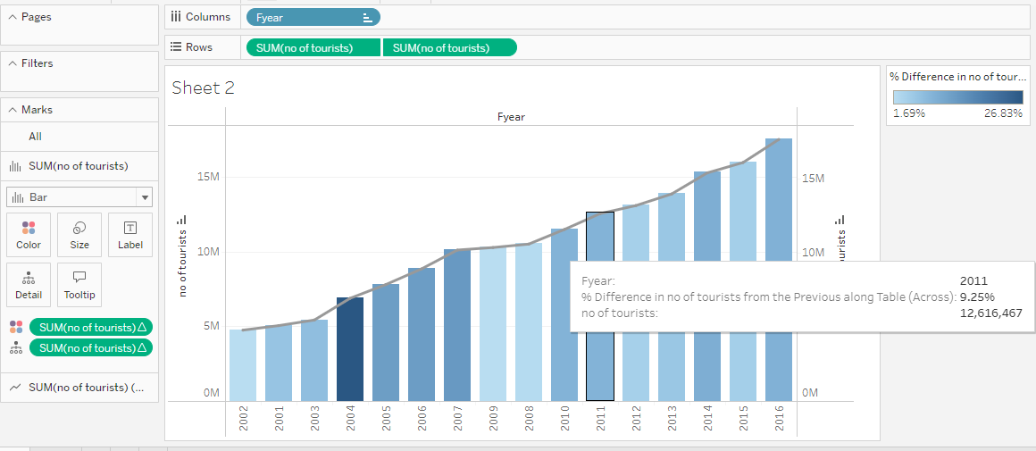

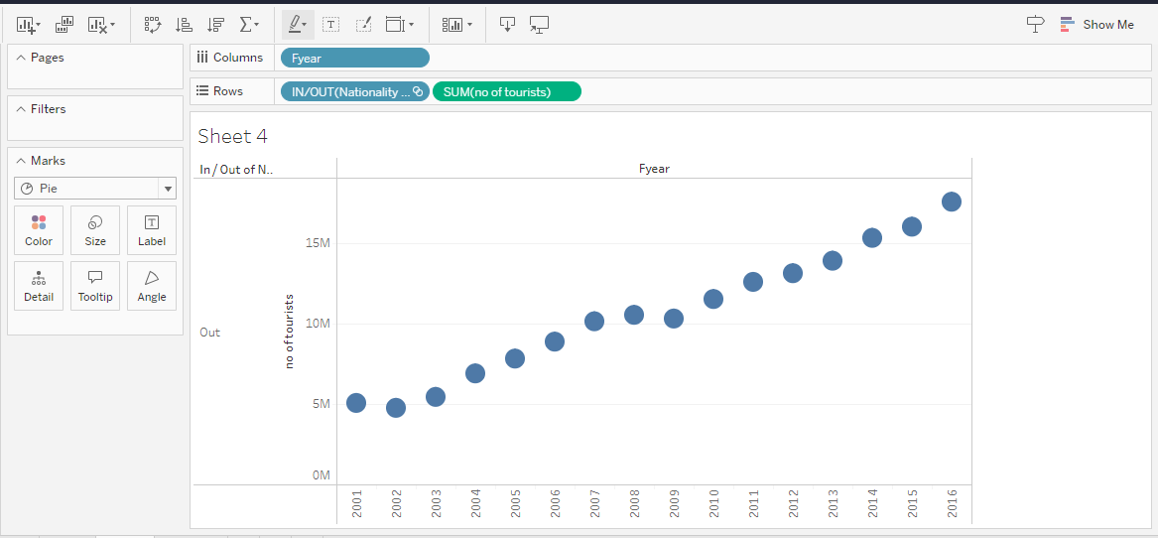

**CHAPTER 5**

**APPLICATIONS/ADVANTAGES :**

### A. Convenience and time-saving

1. **Ability to compare multiple options in one place:**Travel aggregators provide users with a consolidated view of various travel options, allowing them to compare prices, routes, and schedules from multiple providers simultaneously.
2. **Time-saving features such as filters and sorting options:**Aggregators offer convenient tools like filters and sorting options, enabling users to narrow down their search based on preferences such as price, duration, departure times, and more.

### B. Cost savings

1. **Access to discounted rates and deals:**Travel aggregators often negotiate special deals and [discounted rates](https://www.roomex.com/blog/hotel-business-rate) with travel providers, allowing users to access exclusive offers that may not be available elsewhere.
2. **Ability to compare prices across multiple platforms:** Aggregators enable travelers to compare prices across different providers, ensuring they get the best possible value for their money.

### C. Wide range of options

1. **Comprehensive search results from various airlines, hotels, and car rental companies:**Travel aggregators compile information from numerous travel providers, offering a vast selection of flights, accommodations, and car rental options.
2. **Variety of destinations and travel packages:**Aggregators cover a wide range of destinations and offer diverse travel packages, catering to different preferences and budgets.

### D. User reviews and ratings

1. **Valuable insights from other travelers:**Travel aggregators often feature user reviews and ratings, providing valuable insights into the quality and experience of specific airlines, hotels, and other travel services.
2. **Helps in making informed decisions:**User reviews and ratings allow travelers to make more informed decisions based on the experiences of others, helping them choose the best options .

**CHAPTER 6**

**CONCLUSIONS & FUTURE SCOPE:**

Overall, the results of the study show that industry is highly competitive. Yatra may dominate in some parameters, but it is not totally dominant. In fact, it does not dominate in terms of price, which gives scope for competitors as economy customers are highly price-sensitive. Also, it does not dominate in terms of web traffic, which again gives scope for competitors as customers are increasingly engaged in social media. Thus, the industry is likely to be in a constant state of flux.

There are several limitations inherent in the study. The study considered only certain criteria, but these may not be sufficient to capture all aspects of tourism aggregators. Further, each of the criteria have sub-criteria, and a direct pairwise comparison of the criteria may be misleading. Also, pairwise comparison of the tourism aggregators under some criteria may be difficult due to contradictory assessments under the sub-criteria. A hierarchical AHP approach may be more suitable in this context. Finally, the data was collected from the websites at a particular point in time; due to the nature of dynamic pricing, however, there could be random fluctuations in prices at the time of the sampling, so that the sample prices may be extreme values, not necessarily reflecting the true distribution of prices. To overcome this limitation, data would have to be resampled over a period of time.